Create an EC2 Instance on AWS Cloud using Terraform
Objective
Create an EC2 instance on AWS Cloud using Terraform with Ubuntu AMI and t2.micro instance type.
Prerequisites
- AWS Account
- AWS CLI configured
- Terraform installed
- IAM user with EC2 permissions

Step 1: Configure AWS CLI
Install and configure AWS CLI.
Check AWS CLI installation:
aws --version
Configure AWS credentials:
aws configure
Enter:
AWS Access Key ID:
AWS Secret Access Key:
Default region name: ap-south-1
Default output format: json

Step 2: Create Terraform Directory
Create a project folder:
mkdir terraform-ec2
Navigate into the folder:
cd terraform-ec2

Step 3: Create Terraform Configuration File
Create a file:
main.tf
Add the following Terraform code:
provider "aws" {
region = "ap-south-1"
}

resource "aws_instance" "ubuntu_server" {

ami = "ami-0461b1436c9b3c1a3"
instance_type = "t2.micro"

tags = {
Name = "Ubuntu-EC2-Server"
}
}

output "instance_id" {
value = aws_instance.ubuntu_server.id
}

output "public_ip" {
value = aws_instance.ubuntu_server.public_ip
}

output "public_dns" {
value = aws_instance.ubuntu_server.public_dns
}

Step 4: Initialize Terraform
Initialize Terraform providers:
terraform init
Output:
Terraform has been successfully initialized!

Step 5: Validate Terraform Configuration
Check Terraform syntax:
terraform validate
Output:
Success! The configuration is valid.

Step 6: Create Terraform Execution Plan
View the resources Terraform will create:
terraform plan
Terraform will display:
Plan: 1 to add, 0 to change, 0 to destroy.

Step 7: Create EC2 Instance
Deploy the EC2 instance:
terraform apply
Enter confirmation:
yes
Output:
aws_instance.ubuntu_server: Creation complete

Apply complete! Resources: 1 added, 0 changed, 0 destroyed.

Step 8: Verify EC2 Instance
Check Terraform output:
terraform output
Example:
instance_id = i-xxxxxxxxxxxx
public_ip = xx.xx.xx.xx
public_dns = ec2-xx-xx-xx.compute.amazonaws.com

Step 9: Verify in AWS Console
- Login to AWS Console
- Navigate to:
EC2 → Instances
- Select region:
Asia Pacific (Mumbai) ap-south-1
- Verify the instance:
Name: Ubuntu-EC2-Server
Instance Type: t2.micro
AMI: ami-0461b1436c9b3c1a3
State: Running

Step 10: Connect to EC2 Instance
Give permission to key file:
chmod 400 key.pem
Connect using SSH:
ssh -i key.pem ubuntu@<public-ip>
Example:
ssh -i ubuntu-key.pem ubuntu@13.xx.xx.xx

Step 11: Destroy EC2 Instance (Cleanup)
To delete the EC2 instance:
terraform destroy
Confirm:
yes
Output:
Destroy complete! Resources: 1 destroyed.

Terraform Workflow
Write Code
|
terraform init
|
terraform validate
|
terraform plan
|
terraform apply
|
EC2 Instance Created
|
terraform destroy
Result: Ubuntu EC2 instance is successfully created on AWS Cloud using Terraform with the specified AMI and t2.micro instance type.
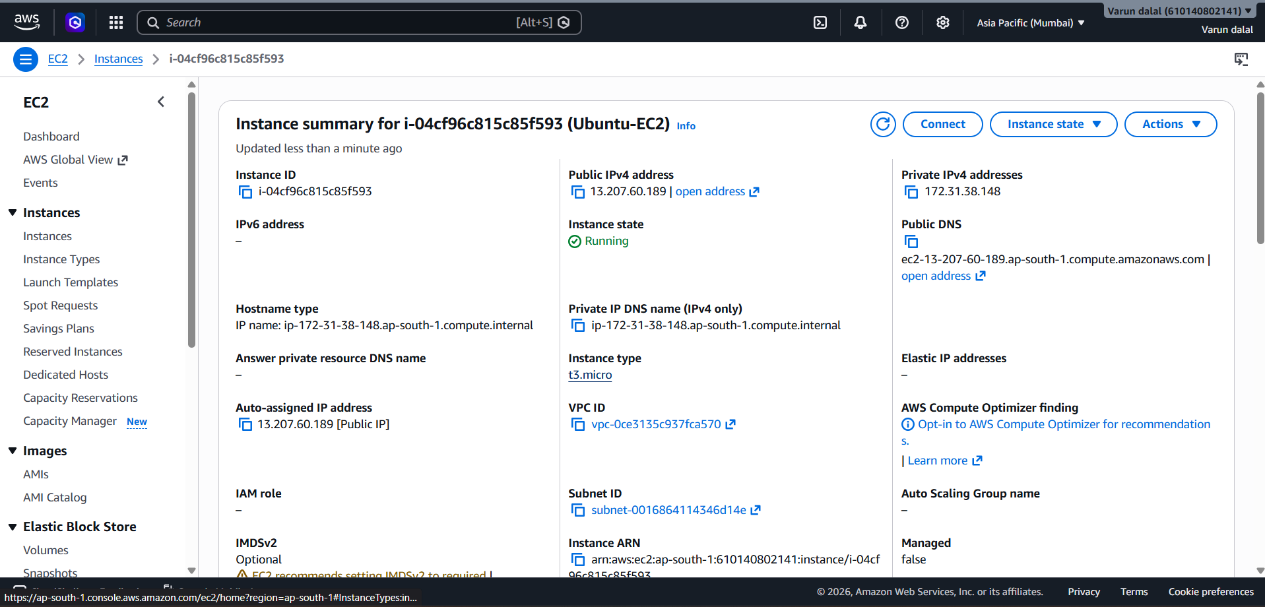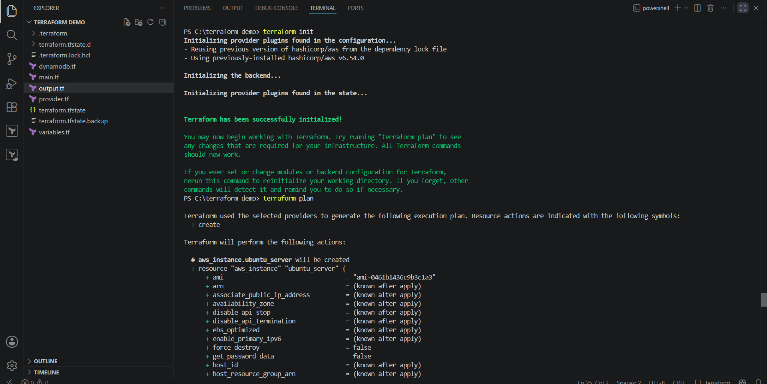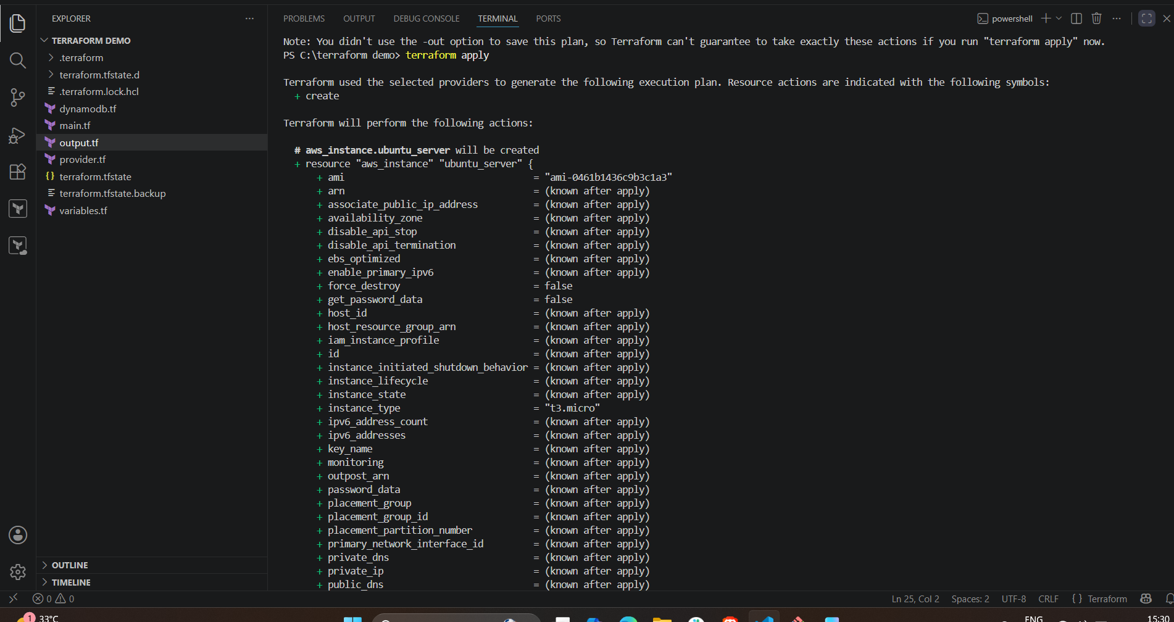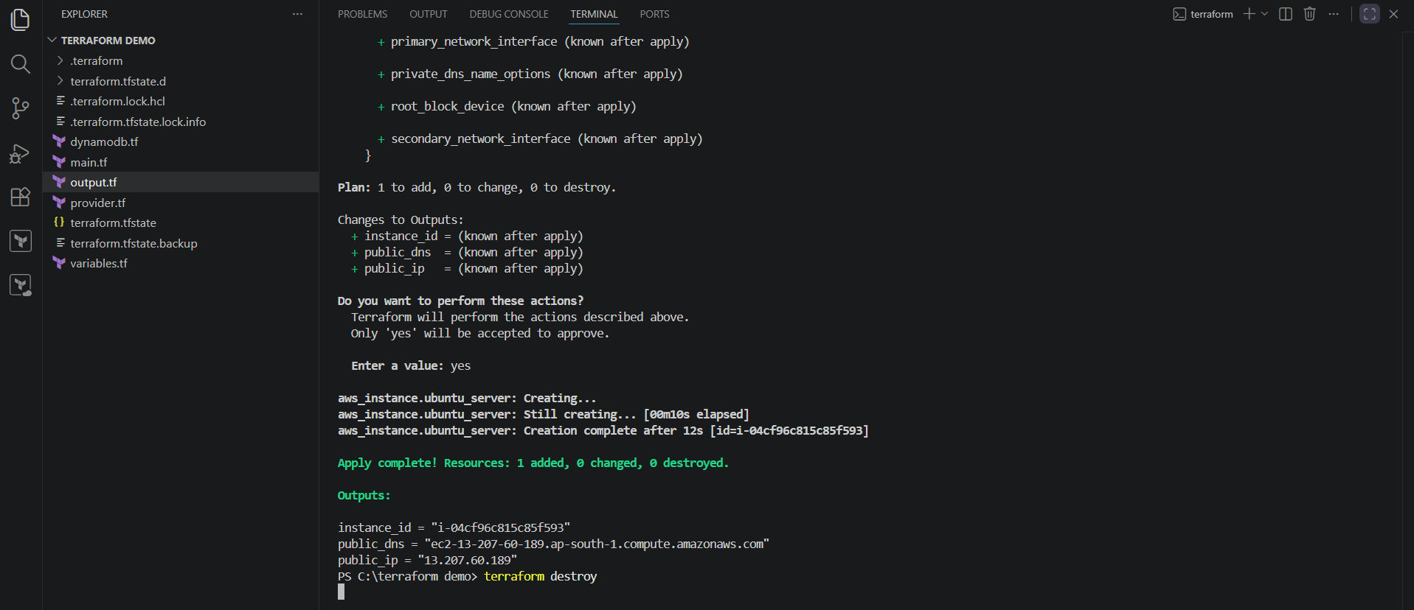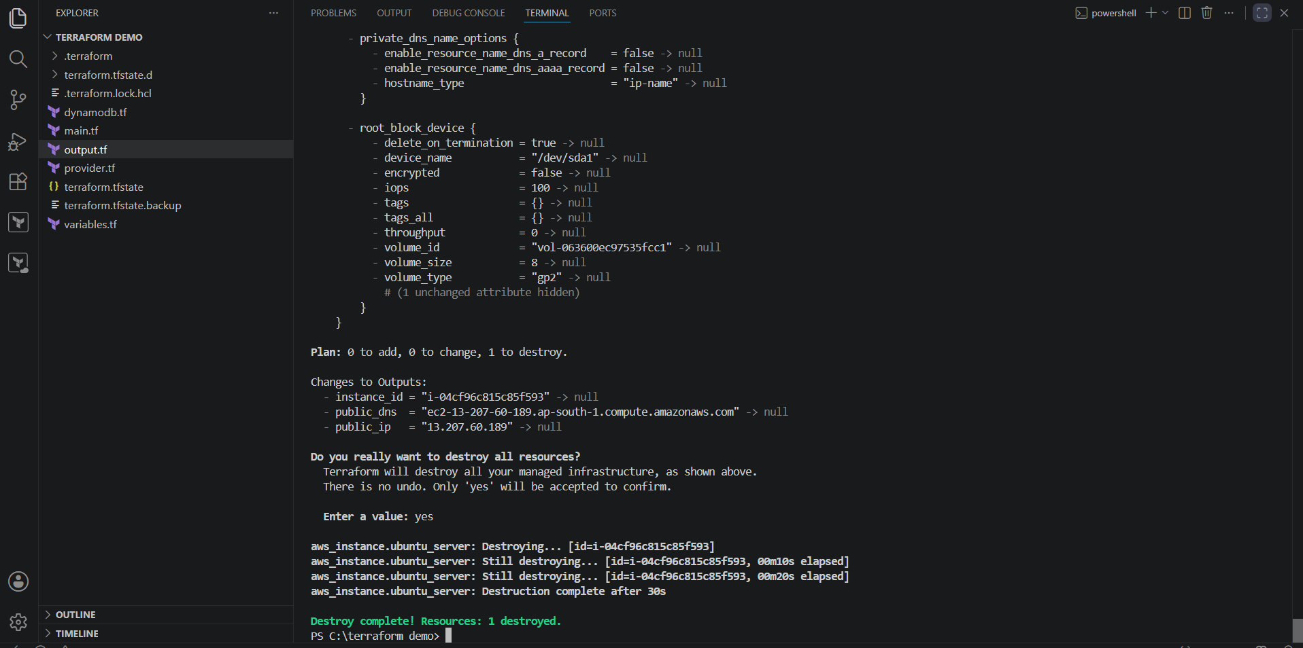

Install Web Server on EC2 Instance and Configure Port 8080
Step 1: Connect to EC2 Instance
Connect to the EC2 instance using SSH:
ssh -i <key-name>.pem ubuntu@<EC2-PUBLIC-IP>

Step 2: Update System Packages
sudo apt update

Step 3: Install Apache Web Server
sudo apt install apache2 -y

Step 4: Check Apache Service Status
sudo systemctl status apache2

Step 5: Configure Apache to Listen on Port 8080
Open Apache ports configuration:
sudo vi /etc/apache2/ports.conf
Change:
Listen 80
To:
Listen 8080
Save and exit.

Step 6: Update Apache Virtual Host Configuration
Open the default virtual host file:
sudo vi /etc/apache2/sites-enabled/000-default.conf
Change:
<VirtualHost *:80>
To:
<VirtualHost *:8080>
Save and exit.

Step 7: Restart Apache Service
sudo systemctl restart apache2

Step 8: Verify Apache is Running on Port 8080
sudo ss -tulnp | grep 8080
Expected output:
LISTEN 0 511 *:8080 *:* apache2

Step 9: Create a Test Web Page
Navigate to Apache web directory:
cd /var/www/html
Create an index file:
sudo vi index.html
Add content:
<html>
<body>
<h1>Apache Server Running on Port 8080</h1>
</body>
</html>
Save and exit.

Step 10: Configure AWS Security Group
Add inbound rule:
Type | Port | Source
Custom TCP | 8080 | 0.0.0.0/0

Step 11: Access Web Server
Open browser:
http://<EC2-PUBLIC-IP>:8080
Output:
Apache Server Running on Port 8080

Result
Apache Web Server is successfully installed on the EC2 instance and configured to listen on port 8080.
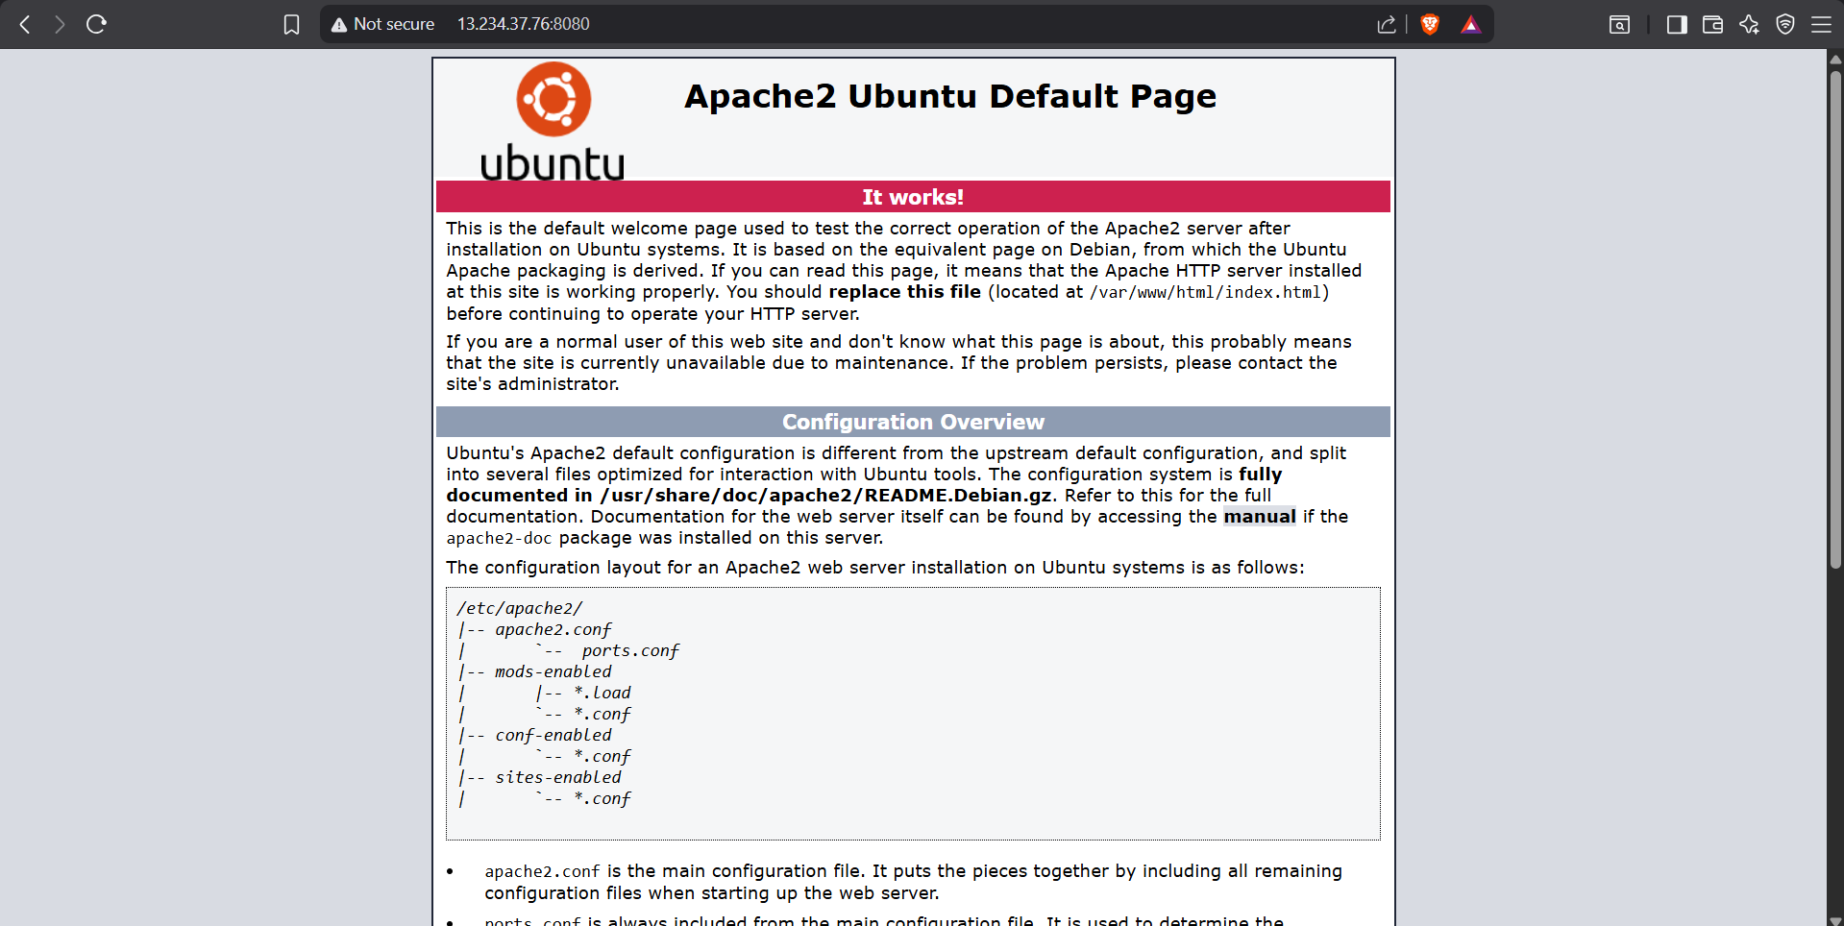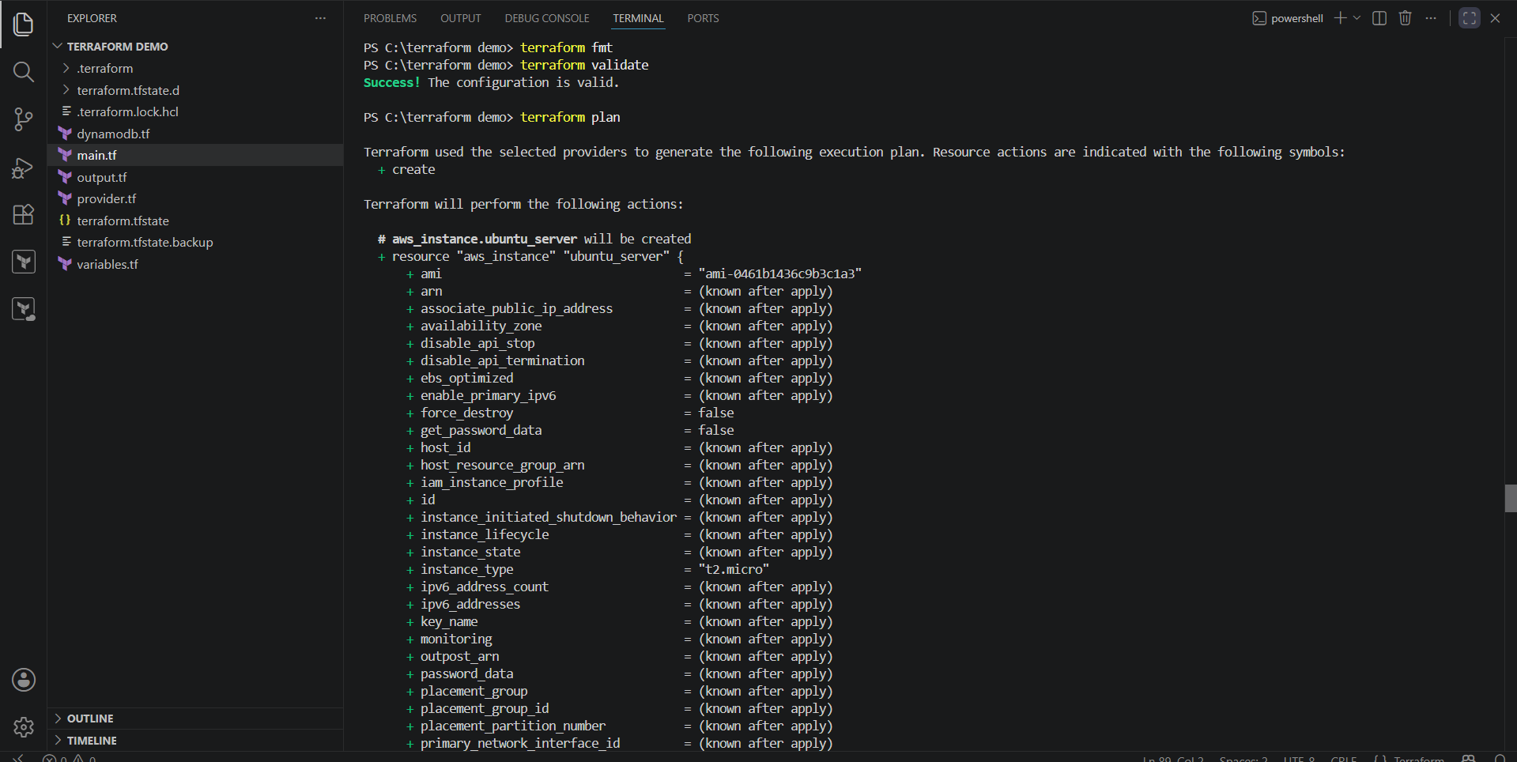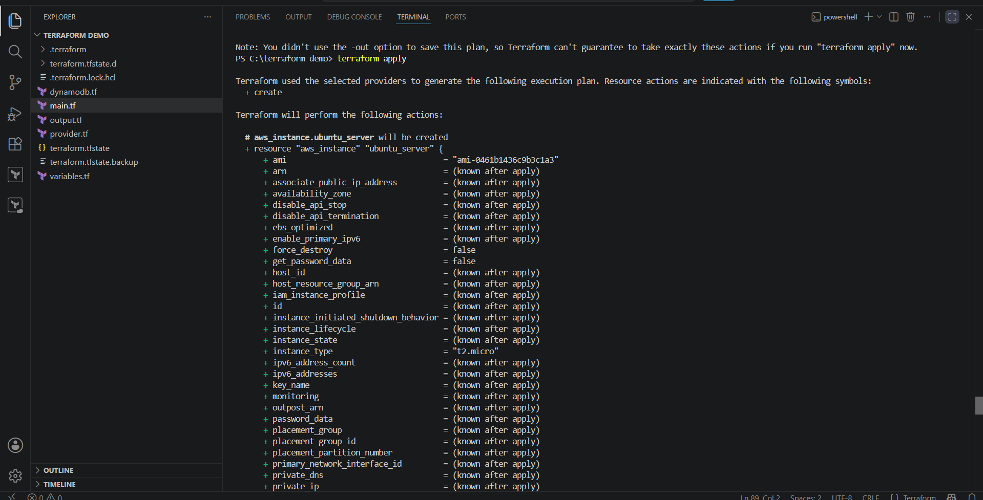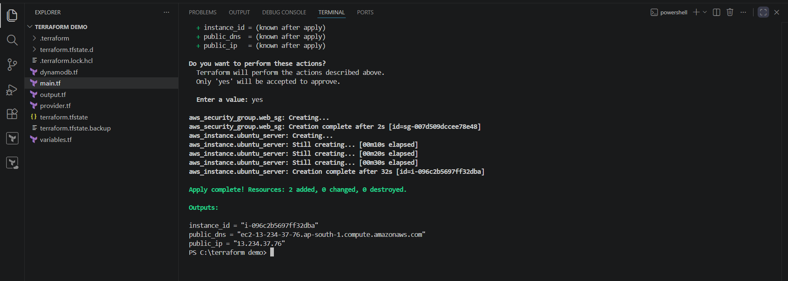

Create a Docker Compose File for the Cricbuzz Hello World Project (Port 8000)
Step 1: Clone the Repository
git clone https://github.com/betawins/cricbuzz-docker-hello-world.git

Step 2: Navigate to the Project Directory
cd cricbuzz-docker-hello-world

Step 3: Create a docker-compose.yml File
Create the file:
touch docker-compose.yml
Or on Windows:
New-Item docker-compose.yml -ItemType File

Step 4: Add the Following Content
services:
cricbuzz-app:
build: .
container_name: cricbuzz-container
ports:
- "8000:8080"
restart: always
Save the file.

Step 5: Verify the Project Structure
cricbuzz-docker-hello-world/
├── Dockerfile
├── docker-compose.yml
├── go.mod
├── go.sum
├── main.go
└── README.md

Step 6: Build and Start the Application
docker compose up --build -d

Step 7: Verify the Running Container
docker ps

Step 8: Test the Application
Open a web browser and visit:
http://localhost:8000
Or test using:
curl http://localhost:8000

Step 9: Stop the Application
docker compose down

Result
The Docker Compose file builds the application image, starts the container, and maps host port 8000 to container port 8080, allowing the application to be accessed at:
http://localhost:8000
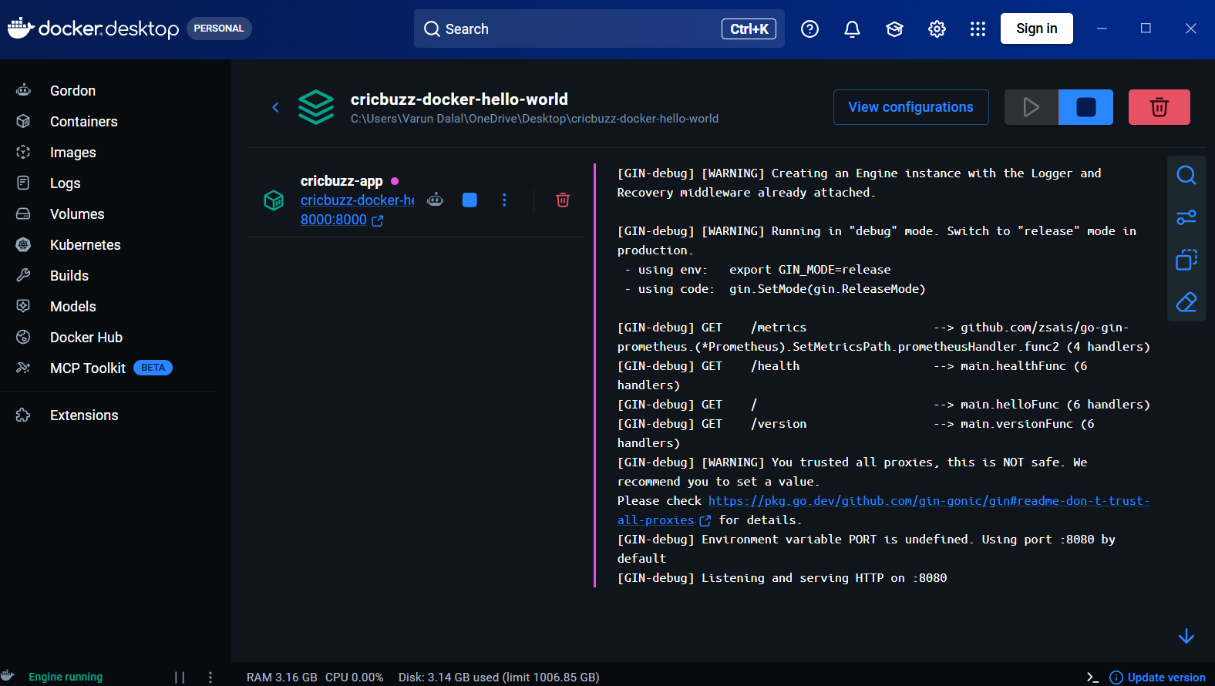

Configure Apache Web Server to Save Logs in /var/log/cb.log
Step 1: Create HTML Page
Create an index.html file in Apache document root:
sudo nano /var/www/html/index.html
Add the following content:
<!DOCTYPE html>
<html>
<head>
<title>Apache Web Server</title>
</head>
<body>
<h1>Hello World</h1>
</body>
</html>
Save and exit.

Step 2: Check Apache Configuration
Open the Apache VirtualHost configuration:
sudo nano /etc/apache2/sites-available/000-default.conf
Update the configuration:
<VirtualHost *:8080>

ServerAdmin webmaster@localhost
DocumentRoot /var/www/html

ErrorLog ${APACHE_LOG_DIR}/error.log
CustomLog /var/log/cb.log combined

</VirtualHost>
Save and exit.

Step 3: Configure Apache Port
Open Apache ports configuration:
sudo nano /etc/apache2/ports.conf
Change the port:
Listen 8080
Save and exit.

Step 4: Create Log File
Create the custom log file:
sudo touch /var/log/cb.log
Set ownership:
sudo chown www-data:adm /var/log/cb.log
Set permissions:
sudo chmod 664 /var/log/cb.log

Step 5: Restart Apache Service
Restart Apache to apply changes:
sudo systemctl restart apache2
Check Apache status:
sudo systemctl status apache2
Expected output:
Active: active (running)

Step 6: Verify Apache Listening Port
Check Apache is running on port 8080:
sudo ss -tulnp | grep :8080
Expected output:
LISTEN 0 511 *:8080 *:* users:(("apache2"))

Step 7: Test Web Server
Access the Apache server:
curl http://localhost:8080
Expected output:
<!DOCTYPE html>
<html>
<head>
<title>Apache Web Server</title>
</head>
<body>
<h1>Hello World</h1>
</body>
</html>

Step 8: Verify Log File
Check Apache access logs:
sudo cat /var/log/cb.log
Expected output:
127.0.0.1 - - [14/Jul/2026:12:15:58 +0000] "GET / HTTP/1.1" 200 374 "-" "curl/7.68.0"

Final Result
Apache Web Server is successfully configured:
- Apache runs on port 8080
- Web content is served from /var/www/html
- Access logs are stored in:
/var/log/cb.log
- HTTP requests are captured successfully in the custom log file.


6. Configure Log Rotation for Apache Log File /var/log/cb.log
Step 1: Create Logrotate Configuration File
Create a new logrotate configuration file for the Apache custom log:
sudo nano /etc/logrotate.d/cb

Step 2: Add Logrotate Configuration
Add the following configuration:
/var/log/cb.log {
daily
rotate 7
compress
delaycompress
missingok
notifempty
copytruncate
su www-data adm
}
Save and exit the file.

Step 3: Configuration Explanation
Configuration | Description
/var/log/cb.log | Specifies the log file to rotate
daily | Rotates the log file every day
rotate 7 | Keeps the last 7 rotated log files
compress | Compresses old log files using gzip
delaycompress | Delays compression until the next rotation
missingok | Does not show an error if the log file is missing
notifempty | Does not rotate empty log files
copytruncate | Copies the log file and truncates the original file without restarting Apache
su www-data adm | Runs log rotation using Apache user and group permissions

Step 4: Validate Logrotate Configuration
Test the logrotate configuration:
sudo logrotate -d /etc/logrotate.d/cb
Expected output:
reading config file /etc/logrotate.d/cb

Handling 1 logs

rotating pattern: /var/log/cb.log after 1 days (7 rotations)

considering log /var/log/cb.log

Step 5: Force Log Rotation (Testing)
To test rotation immediately:
sudo logrotate -f /etc/logrotate.d/cb

Step 6: Verify Rotated Log Files
Check rotated log files:
ls -l /var/log/cb*
Expected output:
/var/log/cb.log
/var/log/cb.log.1.gz

Final Result
The Apache log file:
/var/log/cb.log
is now configured with log rotation.
Features enabled:
- Daily log rotation ✅
- Keeps 7 previous logs ✅
- Compresses old logs ✅
- Handles missing/empty logs safely ✅
- Rotates Apache logs without restarting the service ✅
Log rotation configuration completed successfully.
